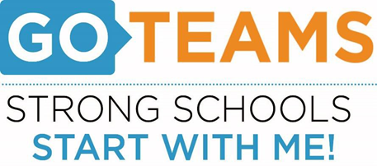

**MEETING NOTICE**

|  |  |  |  |
| --- | --- | --- | --- |
| **School** | **Date** | **Time** | **Location** |
| John Wesley Dobbs | Dec. 6, 2023 | 4:00pm – 6:00pm | [**https://atlantapublicschools-us.zoom.us/j/86844117045?pwd=bWxoZ0FQNktIVndtWXY2Mm4yVEtTdz09**](https://atlantapublicschools-us.zoom.us/j/86844117045?pwd=bWxoZ0FQNktIVndtWXY2Mm4yVEtTdz09)    **Meeting ID: 868 4411 7045**  **Passcode: GoTeam**  **Youtube: Dobbs Elementary**  **@dobbselementaryschool8427** |

**Notice Prepared By:** Sonja Yarbrough **Date Posted: .**

**Meeting Agenda**

(*agenda may be amended*)

*This meeting will allow for Public Comment*

1. Call to Order
2. Roll Call; Establish Quorum
3. Action Item
   1. Approval of Agenda
   2. Approval of Previous Minutes
   3. Rank Priorities
4. Discussion Items
   1. Continuous Improvement Plan Presentation
      1. Continuous Improvement Plan and Strategic Plan Alignment
5. Information Items
   1. Principal’s Report
   2. Cluster Advisory Team Report
6. Announcements
   1. December Highlights
7. Public Comment
8. Adjournment